**MINI PROJECT II**

**(2023-24)**

**RESUME CREATOR**



**Institute of Engineering & Technology Team Members**

**Rishabh tilak**

**` (2115990016)**

**Krishan gopal**

**(2115990007)**

**Sanjay sharma**

**(2115990017)**

**Supervised By Mr. Bhanu Kapoor**

**Department of Computer Engineering & Applications**

**TABLE OF CONTENTS**

Declaration 3

Certificate 4

Acknowledgement 5

Introduction 7

Overview and Motivation 7

Introduction to Problem Statements 8

Objectives- 9

System Requirement Analysis 9

System Analysis 9

Role of System Analyst 10

Users 10

Methodology 10

Requirement Analysis 11

Website Handover: 11

Dependencies/External Systems 12

User Interface: 12

Hardware Interface: 12

Hardware and Software Requirements 13

Hardware Requirements: 13

Software Requirements: 13

Implementation Details 14

Contribution Summary 15

Project Work 15

Benefits and scope of the project 28

Benefits of the Project 28

Future Scope 29

Limitations of System Proposed 29

Conclusion 30

Useful Link:- 30

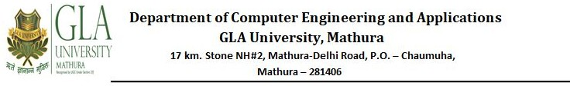

# Declaration

I hereby declare that the work which is being presented in the Fullstack using scripting technologies Project “**Resume Creator**”, in partial fulfillment of the requirements for Fullstack using scripting technologies is an authentic record of my own work carried under the supervision of **Mr. Bhanu Kapoor.**

**Rishabh tilak**

**Krishan gopal**

**SanjaySharma**



# Acknowledgement

*Presentation, inspiration, and motivation have always played a key role in the success of any venture*.

Making this project was a great learning experience. During this period of building the project, we learned a lot about web development as well as team work.

We would like to express our special thanks of gratitude to Mr. Bhanu Kapoor Sir for guiding and teaching us throughout this project. We pay our deep sense of gratitude to the GLA University, Mathura for conducting this project.

We are grateful to our parents who have been an important inspiration. We want to thank them for their encouragement which helps us in completion of this project.

**Abstract**

Today’s in this metropolitan world computer science plays a vital role in every individual’s life. Specially, in youngsters and employees as every year a number of young graduates pass out from their college for any professional job and for that every student requires an interactive ,engaging and professional resume for their job interview easily through their digital devices.

For such issues we came up with a project which aids students completely while building their job resume. This project aims to synthesize goal-orientated processes such as problem solving, decision-making, communication and to solve time consuming tasks in less time.

This convenient system of working will take all the major concerns like building resumes, filling forms for different companies, etc. which helps in smooth functioning of the system which in turn leads to better consequences and creates a better coordination between admin and student/employee.

This system’s back-end is constructed using PHP and MySQL to ensure reliable database and its front-end is designed using HTML5, CSS3, Bootstrap and JavaScript to provide a user-friendly interface.

**Introduction**

## Overview and Motivation

This report file gives the complete description of the project titled as “Resume Creator”. It will illustrate various functionalities of the resume building website. It presents the design and development of the website in a descriptive manner that allows the reader to understand each and every aspect related to this project. The project aims to synthesize goal-orientated processes such as problem solving, decision-making, communication and to solve time consuming tasks in

less time.

This project aims at developing a website that builds the online Resume/CV of Students and Employees.

Using this website, people can minimize their tasks. This web application provides aid to people from around the country to build their Resume/CV. It is mainly a web interface for users who are looking for the strong and contrasting Resume/CV to their relevance with many layouts of the pages that will be designed using the Front-end development technologies. This project will be available free of

cost and easy to proceed for the employee or students to build their Resume/CV. Anyone can access this website to build Resume with their University or company layouts and logos on the page.

Using technologies appropriately in a manner to provide the user all the necessary details in less time is one of those good perks of the evolving technologies. Here, in the project

technology is used to deliver all the necessary details of building resumes to leverage the ease and convenience of building resumes for graduates and employees. So this project has been undertaken in response to overcome the challenge of improving fastness and easiness of building resumes.

**Introduction to Problem Statements**

Most of the students did not come with a proper format of resume or many of the students/employees face difficulty while building their profile. They generally feel the difficulty of the interface of the particular application or website.To address this challenge, we need to improve fastness with an easy interface . So to overcome this dilemma we need an application which solves the following problem statements:

* Web application that provides information of various types of resume.
* Web application that is easy to build resumes with an easy interface.
* Web application which is free of cost

**Objectives-**

This website helps the customer to build contrasting Resume/CV. It is designed in such a way that one can build Resume/CV from any place through online and can

save them for later reference. It will provide a quick, free and easy building of the Resume.

# System Requirement Analysis

**System Analysis**

System analysis is a process of collecting and interpreting facts, identifying the problems, and decomposition of the system into its components. It is a process of studying a system in order

to define its goals or purposes and to discover operations and procedures for accomplishing them most efficiently.

Here, we designed a website through which students and employees will be able to build their resume in a minimal amount of time so that they can prepare themselves for their conversation interview not on building resumes.

**Role of System Analyst**

The system analyst is a person who is thoroughly aware of the system and guides the system development project by giving proper directions. She/he is an expert having technical and interpersonal skills to carry out development tasks required at each phase. Some of the main roles of system analyst are:

* Defining and understanding the requirements of users through various fact finding techniques.
* Prioritizing the requirements by obtaining user consensus.
* Maintains analysis and evaluation to arrive at appropriate system which is more user friendly.
* Draw certain specifications which are easily understood by users and programmers in precise and detailed form.
* Implement the logical design of a system which must be modular.

**Users**

A user is a person who uses or operates the application. The user of the web portal will be students , employees and Admin of this portal only.

**Methodology**

Our methodology is designed in such a manner to help you take maximum advantage of the internet technologies. It incorporates all aspects related to our website and allows us to ensure that the final product is of the highest standards. Below are the steps we will take to ensure that all your deliverables are completed in time, also we will try to solve each and every problem efficiently.

**Requirement Analysis**

The first step for us is to analyze our target market‟s requirements. Who will be visiting our website, what will be the purpose of their visit, what is the primary

goal of our website, how can our team best cater to their needs etc. Many such questions are analyzed for the Needs

Analysis stage. If we are given access to the current website statistics, we would also like to analyze our current page views, average user time spent on the site, top landing pages, existing search engine rankings, existing bounce rates and many such factors. We analyze our online target audience and assess our differentiation strategy to best attract and retain our online visitors.

**Website Handover:**

Once the site is set up on the destination server, upon the approval we make the website live. One final set of testing is done on the live website for the quality assurance purposes, we then hand over the control of the site to admin.

In this project the work is divided into 5 modules. In each module we will be performing the different tasks to reach the target. Modules are as follows. :

* Project software and hardware setup and designing the homepage of Website.
* Creating the layouts of the pages of Resume/CV.
* Backend task will be the fourth module.
* Last module is the backup module to look back at the project working and make it better.

**Dependencies/External Systems**

### User Interface:

The webpages of Resume Creator website will permit complete navigation; including all the functionalities, starting from a simple login or registration, to access the necessary information.

### Hardware Interface:

There are external machines/devices used by the portal, each related to a user interface. These are a server machine at the admin end and hosting the portal, a PC keeping log of the registration and login entries made to them & providing them with an interface to do their part of functionality offered, last one is a PC or a smartphone or a tab at the user’s end to access the portal. The devices at the user end behave as terminals and not for storing any type of data. Also capable of taking user input. All order and decisions should be stored on the server.

# Hardware and Software Requirements

**Hardware Requirements:**

* + Computer with RAM greater than 2 GB.
  + Computer with i3 or above versions of Intel processors.
  + Active internet connection provider Wi-Fi module.

**Software Requirements:**

* + Windows 7 or above versions
  + Visual Studio Code
  + Web Browser
  + Xampp
* Github
  + Adobe XD

# Implementation Details

To implement is defined as to put something in effect.

We have designed the website‟s front-end using HTML5, CSS3, Bootstrap, and some basics of JavaScript to provide a user-friendly interface. And its back-end is constructed using PHP and MySQL to ensure a reliable database. To make implementation details more clear here are

some of the highlighting points:

* + To implement homepage in an efficient way.
  + To enable users to add their details on a website.
  + To enable users to maintain and update their details.
  + To make the complete login/sign-up process easy.
  + To make the complete resume/profile process easy.

**Contribution Summary**

This project is completed by 2 members of the team. So, their contributions are:

* **Aman Gulwani:**- Front-end, back-end,different view panels, synopsis and video file of the project along with project handler.
* **Vishal Verma:-** Front-end ,back-end ,data collector ,presentation file and report file of the project.

# Project Work

The online resume creator website is built both for desktop as well as smartphones. However it is also responsive for other digital devices as well like tabs, etc. Front-end of the website is built using HTML5, CSS3, Bootstrap and some basics of JavaScript to provide a user friendly interface. Its back-end is constructed using PHP and MySQL to ensure a reliable database. Website has many parts to showcase and receive information.Here in this project our website will provide information like different templates and frames of building resumes/profiles for students and employees.

Along with this our website receives various vital data from users for creating their interactive resume/CV.

The homepage of the website is the most important page as well as the first impression of the website. Here in the project homepage of the website is strikingly impressive. Anyone who comes to the website for fetching details or login/signup will be welcome by the homepage given below.

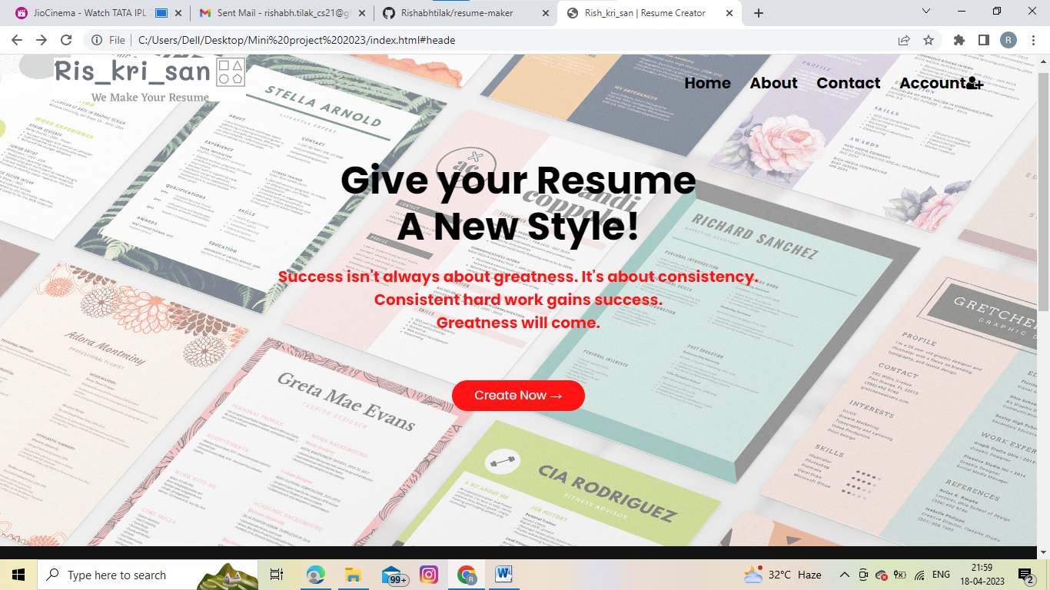

Fig

The homepage of our website has a button of *create now* for styling/building resumes/cv along with this it also contains four useful buttons namely Home , About , Contact and Account .

On the right corner of the header section and on its left side an impressive logo of “Vis_man Resume maker” is given.

When we click the About or Contact us button there will be a smooth scrolling which takes you to the bottom of the page for further details of the developer. Which looks as:

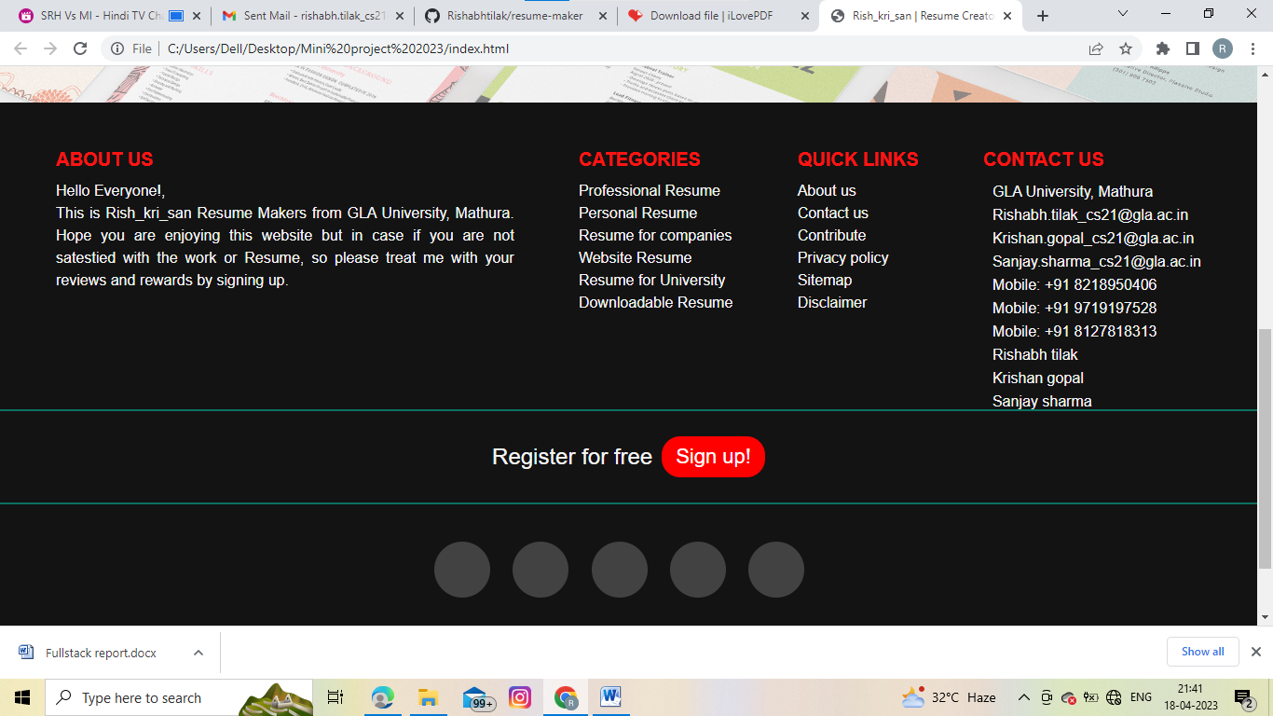

In this one would find a short description of About us for any query or for giving any suggestion after that there is a block of category in which one would be able to find various types of resumes that one can build using this website such as Professional ,Personal resume, for university and for companies.etc.

After that next block is of quick links through which we will quickly view the features and statements of privacy policy,disclaimer etc.

Then finally there is a column of contact us through which one would be able to contact us via gmail or through social media platform or can directly call us.

Then after a horizontal line there is a statement of Register for free followed by a sign up button when we visit this button and another page gets opened for signing up for doing any further process in the website. The sign up page looks like:

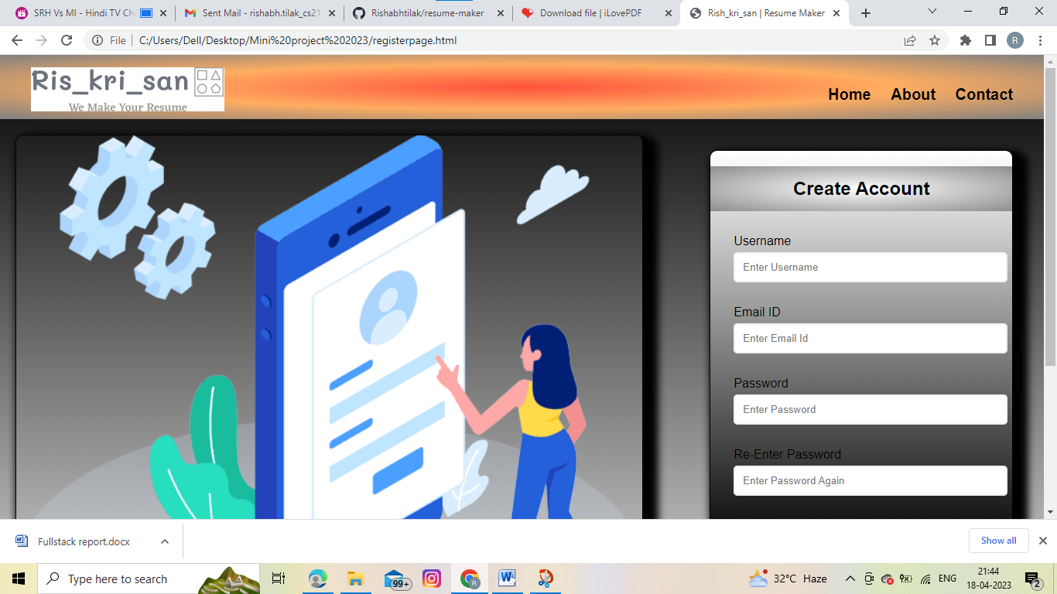

In this sign up page there is a form template on the right side for users for creating their account for which they have to enter their username,an email id,and password

.

Also,this sign up includes a home ,about and contact us button on its header section.

After creating their account one can start styling their cv or resume in a fast and effective way.

Once after signing up on this website one need not to sign up again as their account has been already created.then they have to sign in for that they have click on account button of homepage.

After clicking on the account button of homepage a new internal page gets redirected which appears as:-

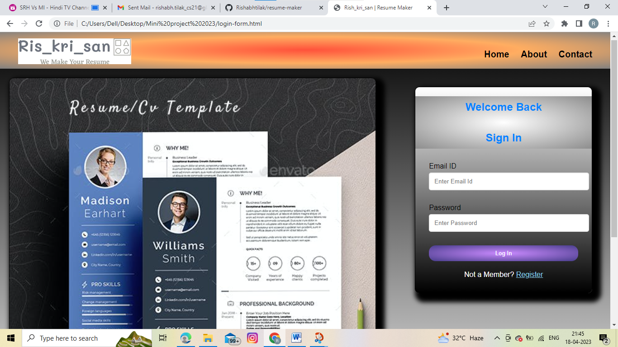

In this page also there is a form template for signing in to access their account for that one need to sign in with their correct credentials of email id and password

,incorrect details won’t be accepted.

In this also there were three buttons on the header section namely home,about,contact us similar to sign up page.

If by mistake one enters on this sign in page without creating their account through sign up then for that there is a statement of “Not a member” at the bottom of the form template of sign in page.

Next to this statement there is a small register button through which one redirects to sign up page then there they can create their account easily after then he/she should be able to use the outstanding features of the website.

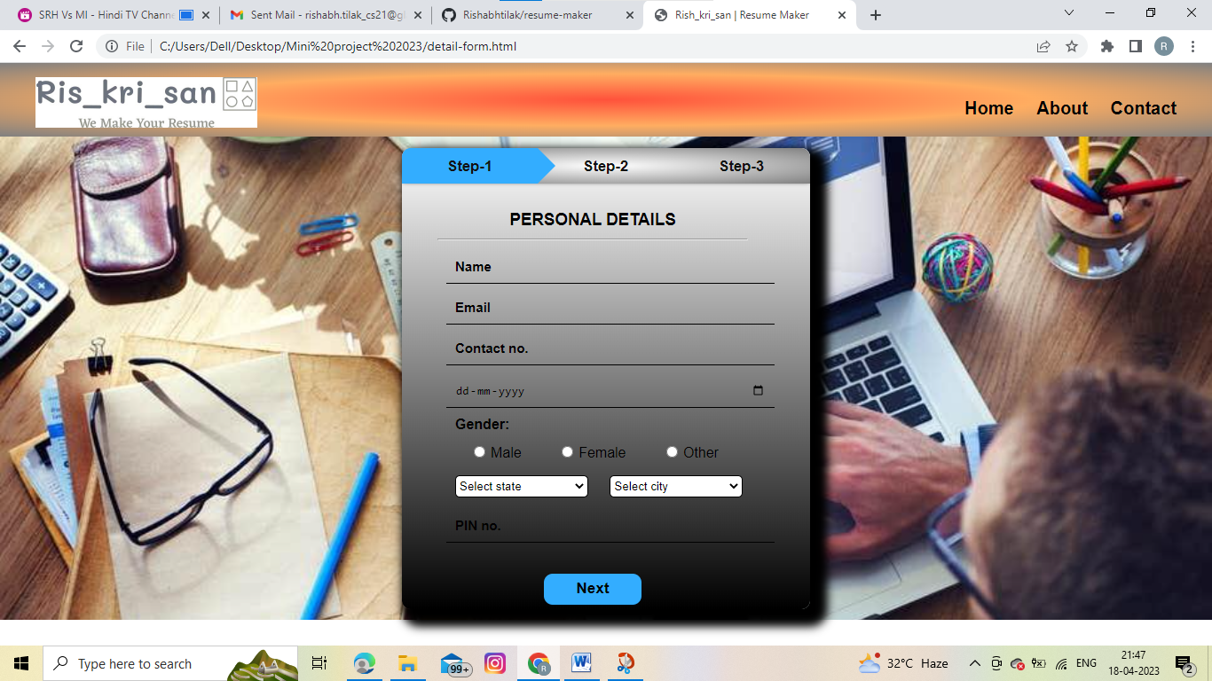

Detail form in three steps to fill the details of the user

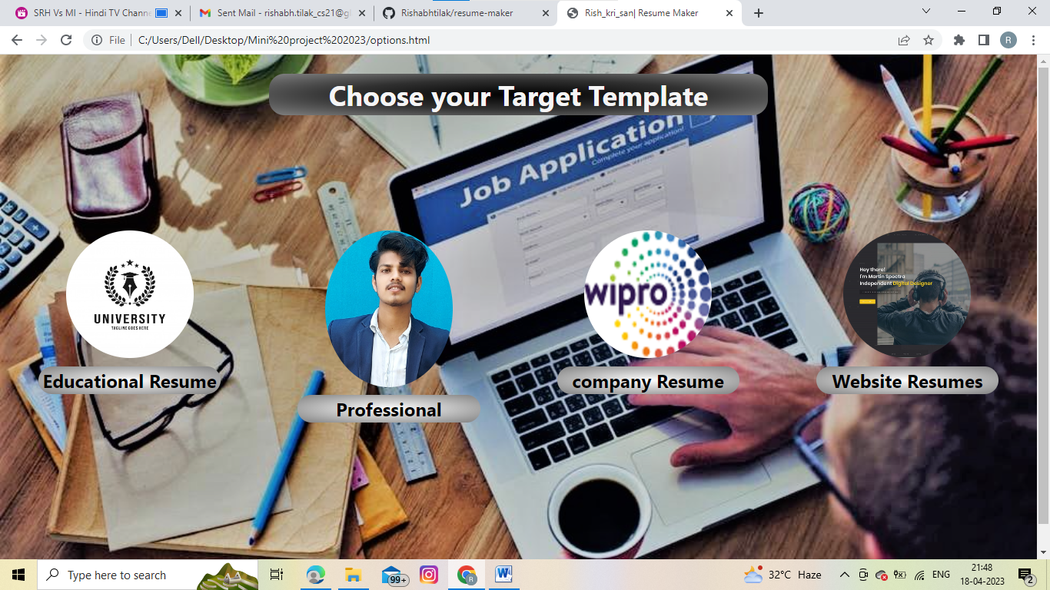

Options to choose the desired templates.

**Below are the some templates options according to the Desired options chosen:**

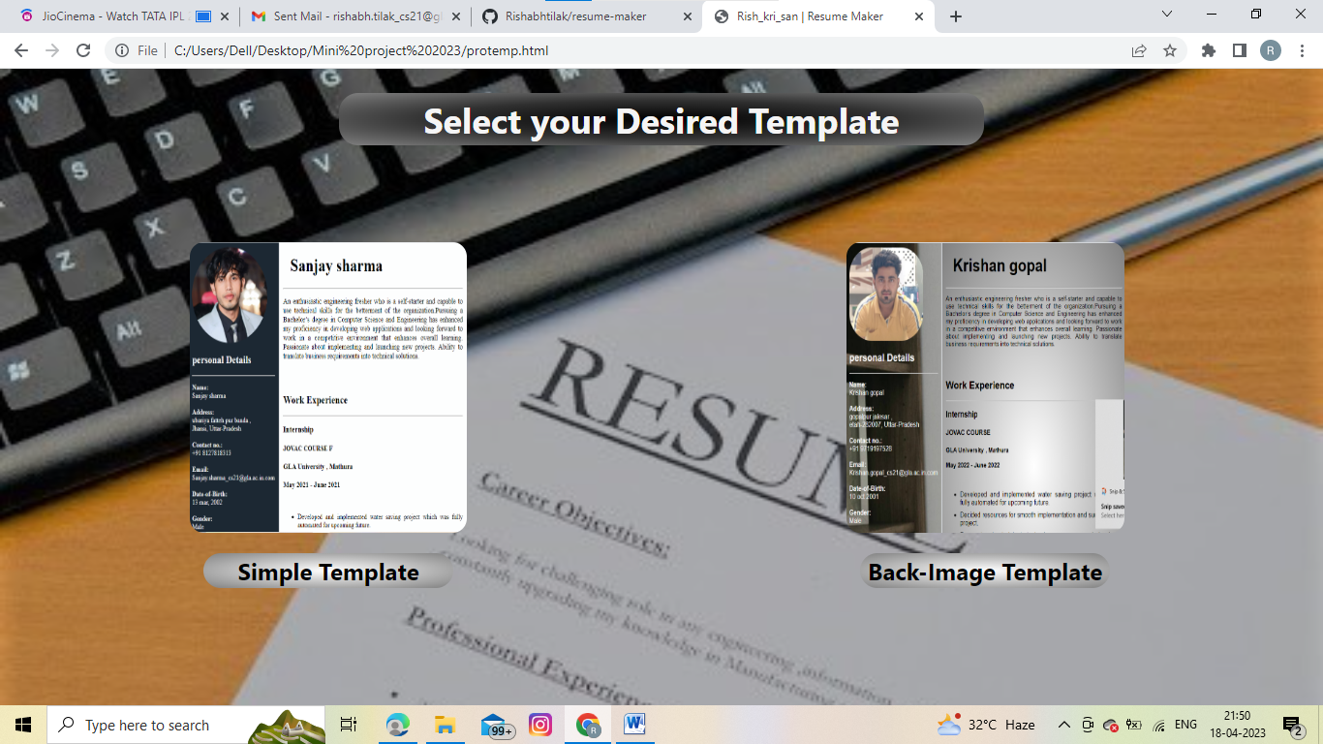

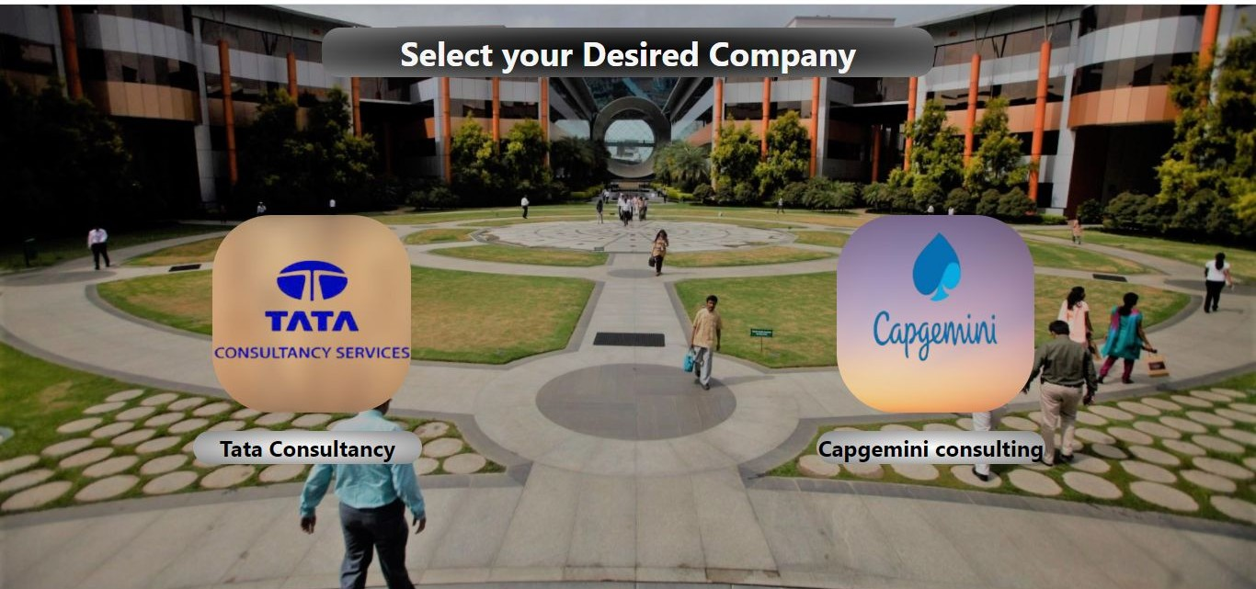

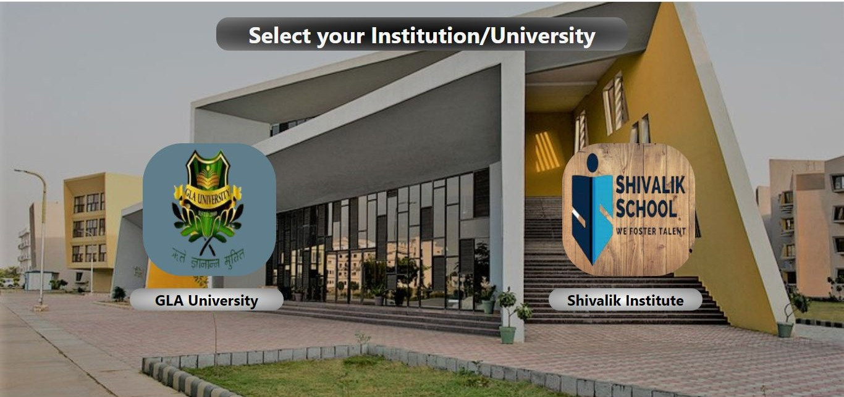

**Below are the some Resumes based on according to the Desired options chosen:**

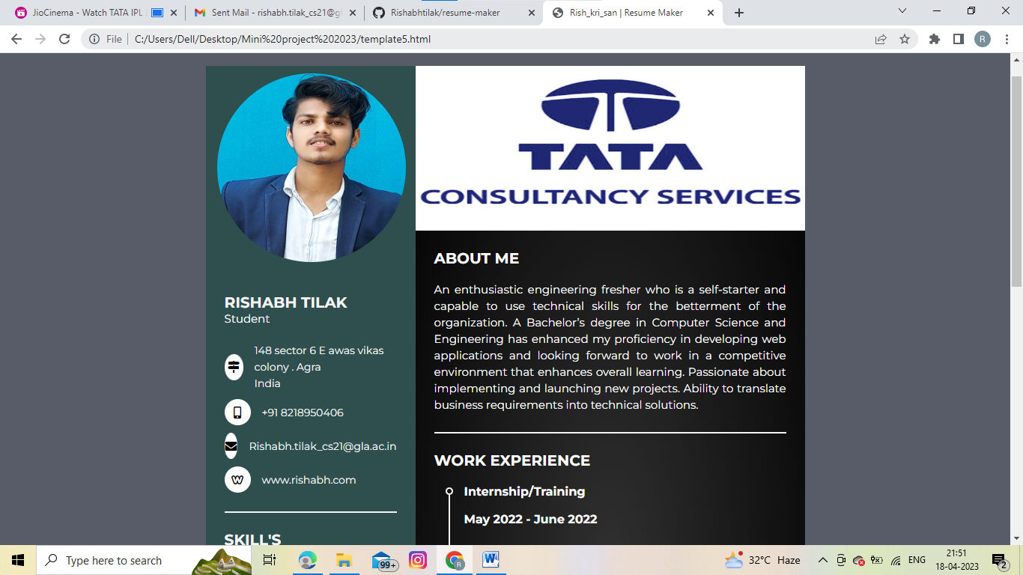

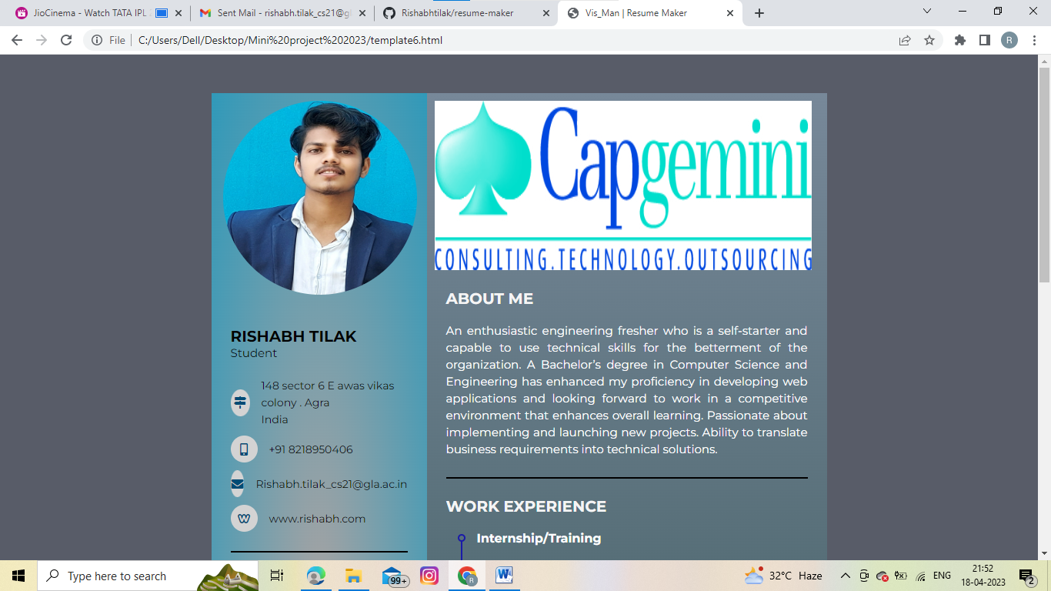

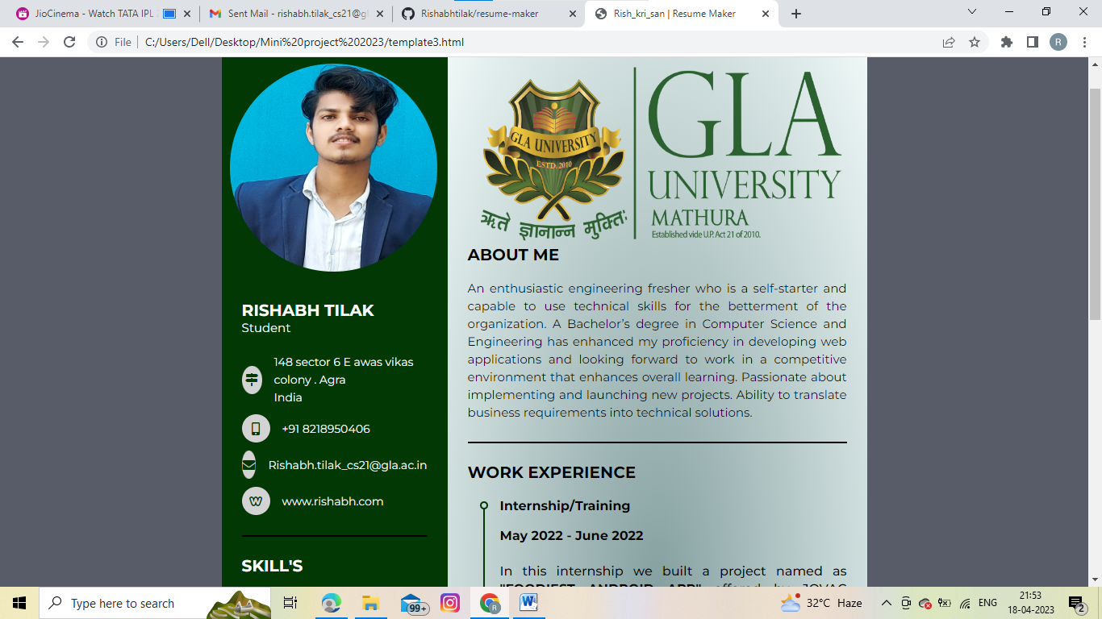

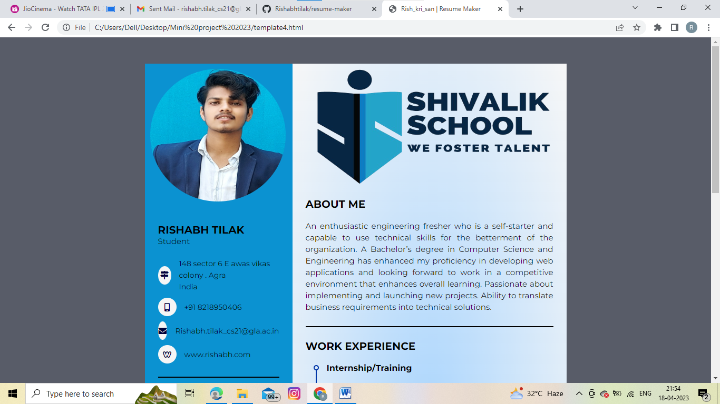

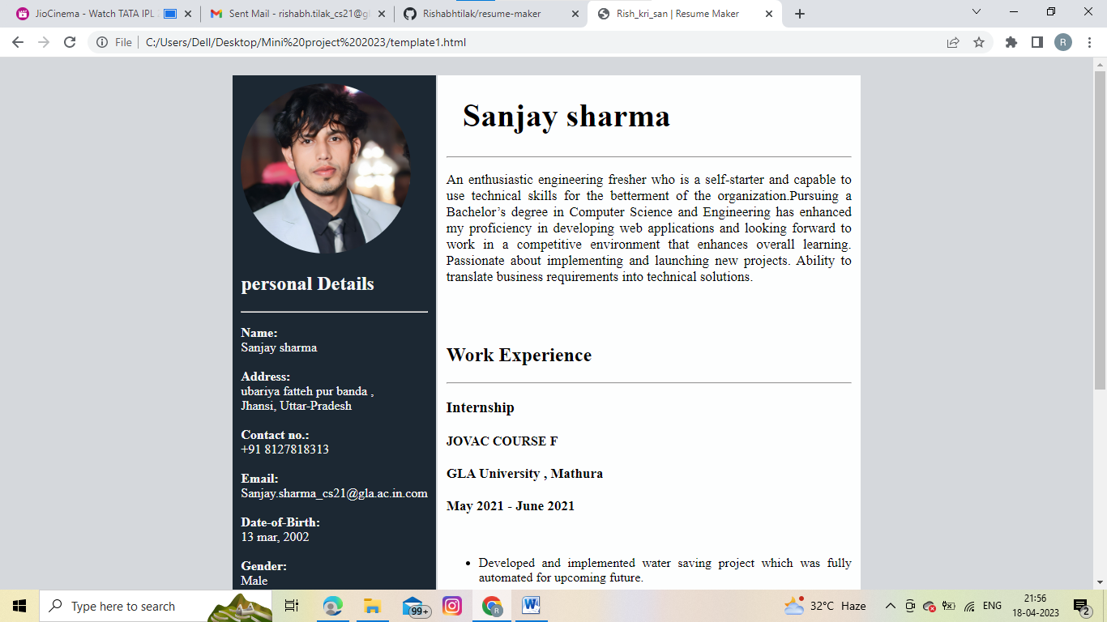

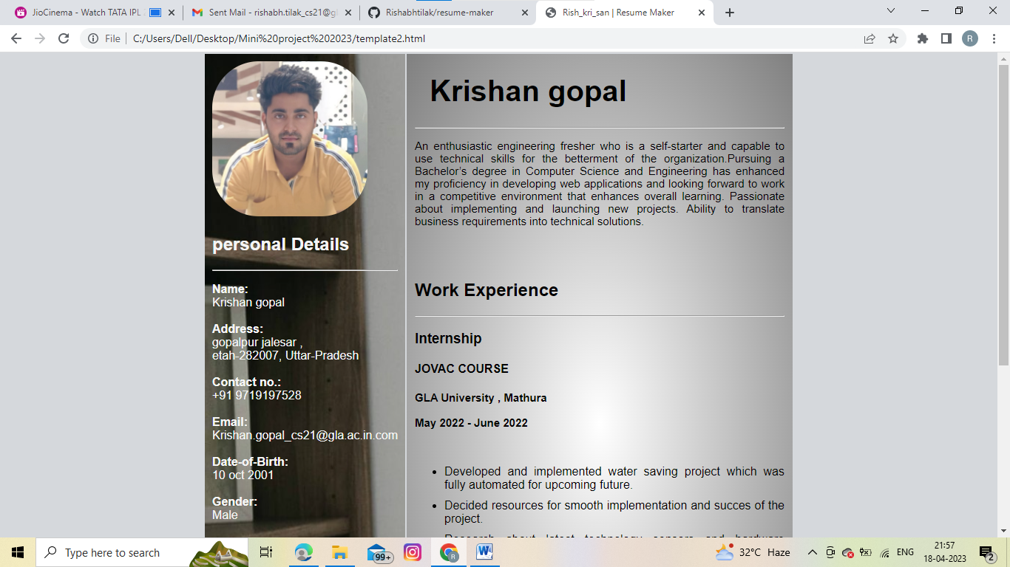

# Benefits and scope of the project

**Benefits of the Project**

Project benefits are the advantages and gains that are delivered by a project. The project “Resume Creator‟ is built to bring benefits for the young graduates and employees.So, to improve the quality of resumes/CV this project provides the following benefits:-

* Easy to design job interviews resumes and CV.
* Fast and effective way to represent yourself in company.
* Easy interface
* Totally free of cost

**Future Scope**

Project already provides many features which are valuable and are enough in most of the cases but improvements are always welcome. So to make the project more valuable than now more features can be added in future like editing and modifying the existing resumes or cv .

For example in most cases students have theirs but they are not update or interactive then modifying the existing resumes will aid the student or employees a lot.

Or in future we can add a chat-bot intelligence through which one would be able to

easily correct their resumes that will play a major role in it.

**Limitations of System Proposed**

* This project is implemented for frontend only, backend is an optional part.
* The page layouts are designed of limited logos of companies or universities only.

# Conclusion

Our intention of this Project was to establish a contrasting, economical, easy and most importantly, a strong Resume/CV creator which can solve our Resume/CV building problems. Our proposed system for Resume/CV building comes under the field of

Frontend web development. Our main objective was to design a website for Resume/CV creator is for easily availing the facility for the Students of our University and Faculty.

**Useful Link:-**

Repository Link:-

**https://github.com/Rishabhtilak/resume-maker**

**References**

* <https://www.w3schools.com/>
* <https://www.beta-labs.in/>
* [www.Youtube.com](http://www.Youtube.com/)

************